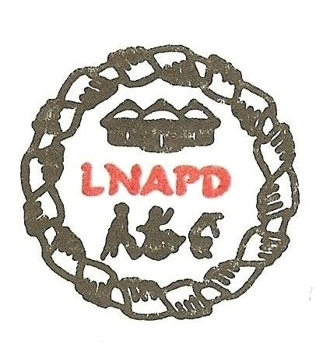

Request for qualification
Position: Executive Director
About LNAPD
The Lesotho National Association of the Physically Disabled (LNAPD) is working to promote and protect the rights and interests of persons with disabilities with the particular focus on the rights of persons with physical disabilities.
LNAPD is registered as a voluntary association of persons with physical disabilities under the Societies’ Act of 1996.
In fulfilling this mandate LNAPD requires a strong leadership and management which will be committed to achieving the goals and objectives of the organisations and be able to think about and implement activities which may sustain LNAPD over the years to come.
It is against this background that LNAPD is looking for a committed and dedicated Executive Director to lead and manage the organization on a voluntary basis as it will be agreed with the board with the intention of retaining the said Executive Director to provide oversight on the general administration of LNAPD as soon as the resource mobilization is being successful.

Roles and responsibilities
- Works with the board to fulfill the mission of LNAPD.
- Responsible for leading LNAPD in a manner that supports and guides the board of directors to achieve the mission of the organization.
- Act as the technical advisor to the board on all policy, leadership and management issues in order to maintain financial integrity and reputation of LNAPD and community outreach.
- Establish and maintain the relationships with various organisations and utilize those relationships strategically to enhance LNAPD mission.
- Supervise the staff to ensure that the defined mission of LNAPD is achieved through programmes, strategic planning and community outreach.
- Establish employment and administrative policies and procedure for all functions and day to day functions of LNAPD.
- Review and approve contracts for services.
- Other duties as may be assigned by board members.
Qualifications and competences
- A bachelor’s degree.
- Transparent and high integrity leadership
- Five or more years’ senior nonprofit management experience
- Experience and skill in working with a Board of Directors,
- High level strategic thinking and planning, Ability to envision and convey the organization’s strategic future to the staff, board, volunteers and donors.
- Ability to effectively communicate the organization’s mission to donors, volunteers and the overall community.
- Demonstrated ability to oversee and collaborate with staff.
- A history of successfully generating new revenue streams and improving financial results.
- Active fundraising experience. Excellent donor relations skills and understanding of the funding community.
- Previous success in establishing relationships with individuals and organisations of influence including funders, partner agencies and volunteers.
- Solid organizational abilities, including planning, delegating, program development and task facilitation.
- Strong financial management skills, including budget preparation, analysis, decision making and reporting.
- Strong written and oral communication skills.
- Strong public speaking ability.
- Strong work ethic with a high degree of energy.
How to apply:
Interested candidates are required to submit their CVs plus their highest qualifications at lesothophysicaldisabilities@gmail.com not later than 15th of January, 2021
Or
The applications should be addressed to:
LNAPD President
P.O Box 7289
Maseru 100

